K.R. MANGALAM UNIVERSITY

Explore a Technology Domain & Create Career Pathway Report

Assignment-3
Submitted By : Rashi Mangal
Roll No. : 2501730043
Course : B.Tech CSE (AI/ML)
Section : B
Course Name : Computer Science Fundamentals & Career Pathways
Course Code : ETCCCP105
Submitted To : Mr. Aryan Sharma
Submission Date : 22 Nov 2025
INTRODUCTION

Being a computer science learner, I’ve looked into major tech areas influencing current digital life. Machines gain decision-making skills through AI by using experience instead of fixed rules. IoT links gadgets so they exchange info and perform actions automatically. Security measures guard networks along with personal details against online dangers. Blockchain keeps transaction records safe, clear, or spread across networks. While cloud computing gives flexible access to digital resources such as data storage and computation power, full stack development handles every layer of web apps - covering user interfaces along with server logic. As a result, these fields highlight key tech advances shaping what comes next.
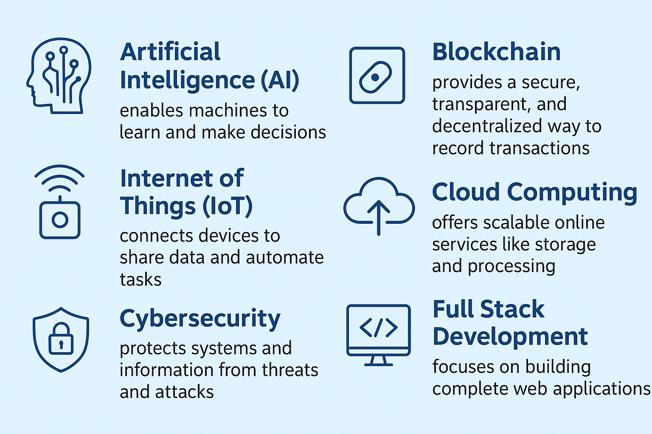

What Is Cloud Computing?

Cloud computing is a technology that enables on-demand access to shared computing resources—such as servers, storage, databases, networks, software, and applications—over the internet. Instead of owning and maintaining physical hardware, users can use these resources remotely through cloud service providers. Cloud computing offers flexibility, scalability, and cost efficiency by delivering IT resources as a service.

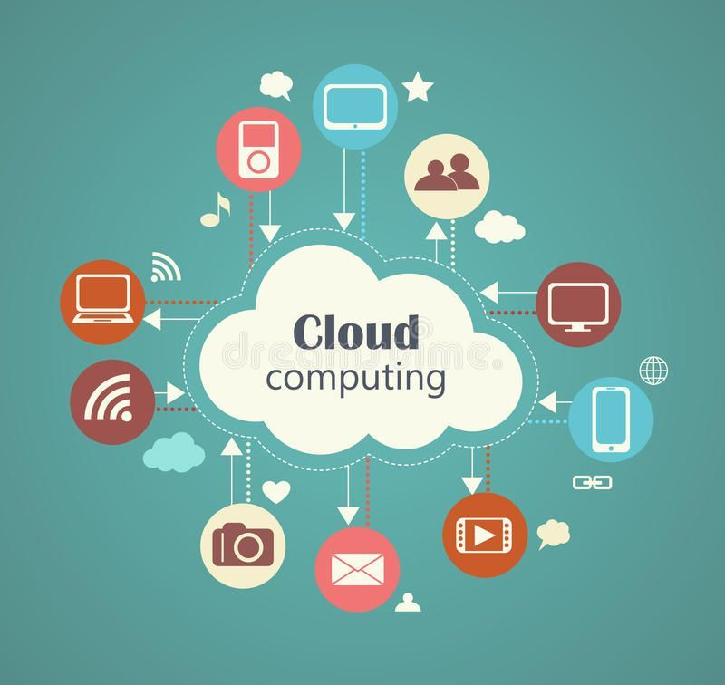

Importance And Relevance In The Current Tech Landscape

- Cost Efficiency: Reduces hardware, maintenance, and operational costs with pay-as-you-go models. Dlf
f
- Scalability & Flexibility: Instantly scale resources based on demand, supporting business growth.
f
- Remote Accessibility: Enables access to data and applications from anywhere, facilitating remote work.
f
- Faster Innovation: Accelerates deployment of applications, updates, and new services.
d
- Enhanced Security: Offers advanced encryption, compliance, and threat detection measures.
f
- Access to Advanced Technologies: Easy integration of AI, big data, IoT, and automation tools.
f
- Competitive Edge: Boosts efficiency, customer experience, and agility for organizations.

KEY TECHNOLOGIES & CONCEPTS:
Major Cloud Platforms
- Amazon Web Services (AWS)
Powers Netflix’s scalable video streaming platform globally.
- Microsoft Azure
Enables enterprises to run hybrid cloud applications with seamless integration.
- Google Cloud Platform (GCP)
Provides advanced AI and data analytics for business like spotify.
- IBM Cloud
Supports enterprise AI solutions with Watson services.
- Oracle Cloud
Delivers high-performance database services for large enterprises.

Definition of IaaS, SaaS and PaaS
The three foundational cloud service models, each providing a different level of control and management to users.
- Infrastructure as a Service (IaaS) : Provides virtualized computing resources like servers, storage, and networks over the internet. Users manage applications and OS, while the provider handles hardware.
- Platform as a Service (PaaS) : Offers a complete platform with tools, runtime, and environment for developers to build and deploy apps. Users focus on coding while the provider manages infrastructure and middleware.
- Software as a Service (SaaS) : Delivers fully functional applications over the internet through a subscription or browser.
Users only use the software; everything else is managed by the provider.

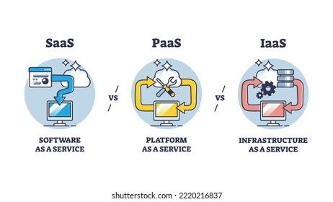

Related Technologies
Virtualization - Creates simulated environments using real hardware, allowing multiple virtual machines to run on a single physical system. It improves resource utilization and separates workloads safely.
Hypervisor - Software that manages and runs virtual machines by dividing hardware resources like CPU and memory. It ensures each VM stays isolated and doesn’t interfere with others.
Containers - Lightweight units that package an app with its dependencies while sharing the host OS kernel. They start quickly, use fewer resources, and run consistently across environments.
Real World Use Cases:
Indian Examples:
- Reliance Jio:
Reliance Jio uses cloud technology to provide scalable network services and AI-driven tools across India. This helps deliver fast, flexible digital access to millions.
- Techno India University:
Techno India University uses Google Cloud to automate tasks like scheduling and grading. It supports AI-based learning and improves academic efficiency.
- Tata Communications:
Tata Communications offers secure cloud services and global network solutions. This helps businesses access reliable international digital infrastructure.
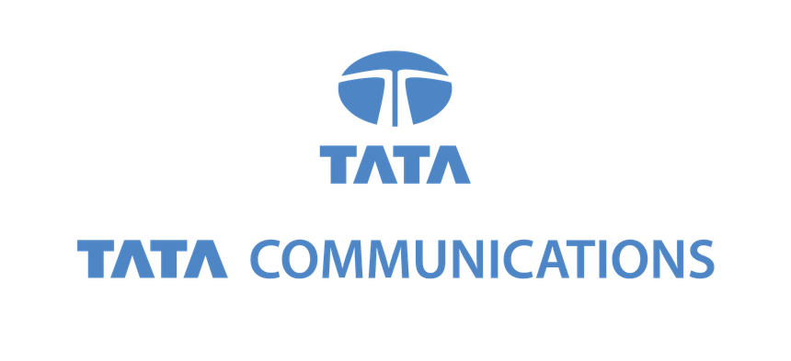
Global Examples:
- Amazon Web Services (AWS):
AWS powers Netflix’s global streaming platform with scalable infrastructure, ensuring smooth and reliable video delivery worldwide.
- Microsoft Azure:
Azure enables companies to build hybrid cloud systems by connecting cloud services with on-premise setups for more flexibility.
- Google Cloud:
Google Cloud supports Spotify by using advanced data processing and algorithms to deliver personalized music recommendations.
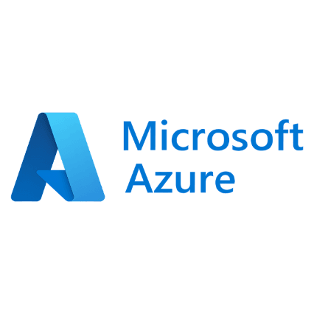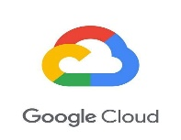

Career Opportunities :

- High demand for roles such as Cloud Engineer, Solutions Architect, DevOps Engineer, and Cloud Security Specialist.

- Required skills include cloud platform proficiency (AWS, Azure, GCP), coding/scripting, networking, and security.

- Career paths often start from cloud support or administrator roles, progressing to engineering, architecture, and security leadership.

- Certifications like AWS Certified Solutions Architect, Azure Solutions Architect Expert, and Google Cloud Professional Cloud Architect boost career growth.

- Cloud professionals work in diverse industries including IT, finance, healthcare, e-commerce, and education with competitive salaries.
HOW CLOUD COMPUTING ALIGNS WITH MY ACADEMIC INTERESTS AND CAREER GOALS?

Cloud computing fits my focus on current tech that boosts performance, scale, supports flexible processes. It links clearly to topics I study - like networks, OS design, memory setups, coding tasks. From a job view, it opens paths into cloud operations, development roles, protection systems, information handling, machine learning work. As many organizations rely heavily on remote servers today, gaining expertise here lets me develop practical solutions, adapt fast, play a part in meaningful digital progress.

CURRENT RELEVANT SKILLS I POSSESS:

- Basic Programming Knowledege (Python, C, C++)
- Understanding of computer networks and operating systems
- Experience with Git/GitHub
- Good problem-solving and analytical skills
- Strong communication and teamwork abilities

SKILLS I PLAN TO DEVELOP FOR A CARRER IN CLOUD COMPUTING:

- Getting skilled in cloud systems: studying tools from top providers such as AWS, alongside Azure, also Google Cloud.
- Learning virtualization and container tech through practical work with VMs, Docker, or Kubernetes.
- Developing skills in network and security setups: exploring VPCs, firewalls, IAM controls, data protection through encryption, while designing safe cloud systems using logical structures instead of standard patterns.
- Boosting automation know-how: Apply CI/CD systems, use Terraform for setup tasks, or write scripts in Python and Bash to streamline work.
- Building core skills in system admin: learning Linux, managing servers, handling storage, also improving performance in cloud setups.
CONCLUSION:

Cloud computing lets people use storage, servers, databases, or apps over the internet on demand. Its flexibility cuts expenses while enabling access from nearly anywhere. With rising needs in AI, data analysis, IoT, yet automation, reliance on cloud infrastructure is increasing. The system aids distant teamwork, quicker upgrades, besides improved protection. As companies shift work online at increasing speed, cloud computing boosts innovation through improved efficiency. Despite shifts in tech trends, it still offers strong job prospects ahead.

References:
- GeeksforGeeks - Cloud Computing Basics and Types
(https://www.geeksforgeeks.org/cloud-computing/)
- AWS Official Documentation and Case Studies
(https://aws.amazon.com/what-is-cloud-computing/, https://aws.amazon.com/solutions/case-studies/)
- Microsoft Azure Cloud Documentation and Blog
(https://azure.microsoft.com/en-us/resources/cloud-computing-dictionary/)
- TechTarget - Cloud Computing Career and Role Guides
(https://www.techtarget.com/whatis/feature/Top-7-cloud-computing-careers-and-how-to-get-started)

